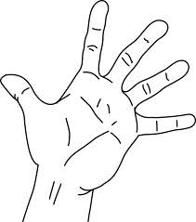
1. Sit to the left side of the patient, patient facing up (supine). Locate navel point or mid-point, measure half way between your thumb and little finger
½ below locate bottom point - rub fingers in a circle counter clockwise
½ above locate upper point - rub fingers in a circle clockwise
(5 minutes)

2. With navel point as the lower point is thumb to little finger measure upward to mid chest lower counter clockwise - upper clockwise (5 minutes)

3. Treating person, move about the head. locate points, 2” left and 2” right of the sternal notch
Rub up and down toward feet then head (30 seconds)

4. Place thumbs at 3rd eye and index fingers at temple, rub in circle head to feet (4.5 minutes)

5. Put index finger, inner eye socket pull. Head to feet (30 seconds)

6. Pat around each ear (30 seconds)

7. Zygomatic arch – rub with pad of thumbs, ear to cheek (30 seconds)

8. Place right base of hand on glabella, left hand over – say your know NO fear (1 minute)

9. Have person turn over and lying on stomach (prone). Do adjustment or massage mid-back (1 minute)

10. Massage mid-gluts, left hand counter clockwise, right hand clockwise, while pushing down left then right (30 seconds)

11. Below glut fold, same rubbing pattern (20 seconds)

12. Mid-thigh, same rubbing pattern (20 seconds)

13. Both knee popliteal fossa, same rubbing pattern (20 seconds)

14. Mid-calf popliteal fossa, same rubbing pattern (20 seconds)

15. Massage Achilles tendons, left then right (20 seconds)

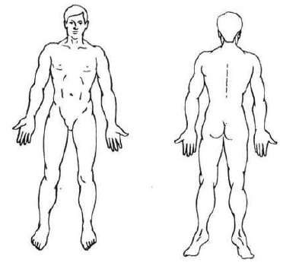
16. Massage inside ankle (20 seconds)

17. Kidney 1 point (20 seconds)

18. Pull toes

19. Pull fingers

